EV Market Segmentation Analysis

Sana Kavya Sri Priya
30/12/24

1. Introduction

The global market for electric vehicles (EVs) has experienced remarkable growth and transformation in recent years, driven by advancements in technology, environmental concerns, and government initiatives promoting sustainable transportation. Simultaneously, the Indian market has emerged as a significant player in the EV sector, with a rapidly growing number of companies embracing this transformative technology.
The global market for electric vehicles (EVs) has experienced remarkable growth and transformation in recent years, driven by advancements in technology, environmental concerns, and government initiatives promoting sustainable transportation. Simultaneously, the Indian market has emerged as a significant player in the EV sector, with a rapidly growing number of companies embracing this transformative technology. In this article, we will compare the global market for EVs with the Indian market, focusing on the key trends, challenges, and the prominent Indian companies leading the charge in the EV sector.
Globally, the adoption of EVs has gained significant momentum, with major automotive manufacturers investing heavily in electric mobility. Countries such as China, the United States, and several European nations have witnessed substantial growth in EV sales, fueled by supportive government policies, improved charging infrastructure, and the availability of a wide range of electric models. This global market expansion has not only propelled advancements in battery technology but also spurred innovations in autonomous driving and vehicle connectivity.
In India, the EV market is in its nascent stage but holds immense potential for growth. The Indian government has undertaken various initiatives and introduced ambitious policies to promote the adoption of EVs. These include tax incentives, subsidies, and setting up charging infrastructure across the country. Several Indian companies have embraced this opportunity and are actively manufacturing and promoting electric vehicles. These companies range from established automotive giants to emerging startups, each contributing to the development and proliferation of EVs in India. In the following sections, we will delve deeper into the global and Indian markets for EVs, exploring the key players, market dynamics, and the future prospects of electric mobility in both contexts.

2. Global Brands and Indian Brands of EVs
When it comes to the electric vehicle (EV) market, there is a notable distinction between global brands and emerging Indian brands. Global brands, consisting of well-established automotive manufacturers, have been at the forefront of EV production and have significant market share worldwide. On the other hand, Indian emerging brands are relatively new players in the EV space but are making rapid strides to establish themselves in this evolving market. Global brands such as Tesla, Nissan, BMW, and Volkswagen have been key drivers of the EV revolution on a global scale. Tesla, in particular, has been a pioneering force, leading the way in electric car technology and achieving remarkable success with models like the Tesla Model S, Model 3, and Model X. These global brands have extensive experience in automotive manufacturing, strong research and development capabilities, and global distribution networks, allowing them to bring advanced EV technologies to the market.
In contrast, Indian emerging brands are making their mark by focusing on the specific needs and preferences of the Indian market. Companies such as Tata Motors, Mahindra Electric, and Hero Electric have emerged as prominent players in the Indian EV landscape. Tata Motors, for instance, introduced the Tata Nexon EV, the country’s first long-range electric SUV, which has gained popularity for its affordability and features. Mahindra Electric has been a frontrunner in electric mobility with its electric cars, such as the Mahindra eVerito, and electric threewheelers. Indian emerging brands often leverage their local knowledge, manufacturing capabilities, and cost-efficiency to cater to the Indian consumer base. They understand the unique challenges of the Indian market, such as affordability, range anxiety, and charging infrastructure, and strive to offer solutions tailored to these requirements. These companies are also actively collaborating with international partners to access advanced technologies and expertise to enhance their EV offerings.

3. Indian EV Market Segmentation
The Indian electric vehicle (EV) market is witnessing significant growth and development, driven by a combination of government initiatives, increasing consumer awareness, and the commitment of Indian automotive manufacturers.

3.1 Problem Statement
The rapid growth and development of the Indian electric vehicle (EV) market have led to a need for a comprehensive analysis of various aspects related to EV segmentation, customer segmentation, and regional growth patterns. While there have been efforts to categorize EVs based on price, speed, efficiency, and seating capacity, as well as identify potential EV customers, and assess the growth of EVs across different Indian states, there are still critical gaps that need to be addressed. The problem statement is to develop a deeper understanding of the Indian EV market by addressing the following key challenges:
- Market Segmentation:
The existing market segmentation of EVs based on K-means clustering needs to be further refined and validated. It is necessary to identify additional variables or factors that significantly influence consumer preferences and purchasing decisions. By considering factors such as driving range, charging infrastructure, vehicle types (sedans, SUVs, etc.), and specific features, we can develop a more accurate and comprehensive segmentation model for the EV market in India.
- Customer Segmentation:
While there have been attempts to segment potential EV buyers, further analysis is required to understand the demographics, psychographics, and specific needs of these segments. By examining factors such as income levels, environmental consciousness, commuting patterns, and consumer preferences, we can develop targeted strategies to effectively communicate and market EVs to the identified customer segments.
- Regional Growth Patterns:
Although the growth of EVs in India varies across states, a more detailed analysis is necessary to identify the specific factors driving or hindering EV adoption in these regions. Understanding the influence of state-level policies, infrastructure development, availability of incentives, and consumer awareness can help identify the states where EV adoption is fastest and where it has the potential for rapid growth.
By addressing these challenges and conducting a comprehensive analysis, we can provide valuable insights and recommendations to stakeholders in the Indian EV market, including automotive manufacturers, policymakers, and charging infrastructure providers. Ultimately, this will contribute to the formulation of targeted strategies to accelerate the adoption and growth of EVs in India, leading to a more sustainable and environmentally friendly transportation landscape.

3.2 ML Techniques Used for Segmentation
In the preprocessing step of our project, we performed several data cleaning and transformation techniques to prepare the data for further analysis. The specific preprocessing steps we undertook include:
- Data Cleaning:
We addressed any missing or inconsistent data values in the dataset. This involved identifying missing values and deciding on appropriate strategies for handling them, such as imputation or removal. Additionally, we resolved any inconsistencies or errors in the data entries to ensure data integrity.
- Data Type
Conversion As part of the preprocessing, we converted objecttype variables to float-type variables when necessary. This conversion was necessary for numerical computations and modeling purposes.
- One-Hot Encoding:
We utilized one-hot encoding to transform categorical variables into a binary representation. This technique creates new binary variables for each category within a categorical feature, allowing us to incorporate categorical data into our analysis effectively.
- Mapping:
In cases where categorical variables had an ordinal nature, we employed mapping techniques to assign numerical values in a meaningful order. This ensured that the ordinal relationship among categories was preserved during subsequent analysis.
- Scaling:
To normalize the numerical variables and bring them to a similar scale, we applied a robust scaler. The robust scaler technique, such as the RobustScaler from scikit-learn, is resilient to outliers and provides robust scaling of the data, making it suitable for handling data with varying scales and potential outliers.
By performing these preprocessing steps, we aimed to ensure data quality, address data inconsistencies, convert variables to appropriate types, handle categorical variables, and normalize numerical data. This prepared the dataset for subsequent analysis, modeling, and interpretation, providing a solid foundation for extracting meaningful insights from the data.

3.3 Market Segmentation Data visualization
In the global market, speed is a crucial feature for electric vehicles (EVs). The availability of fast and exhilarating experiences in EVs can attract speed enthusiasts, encouraging their transition towards electric mobility
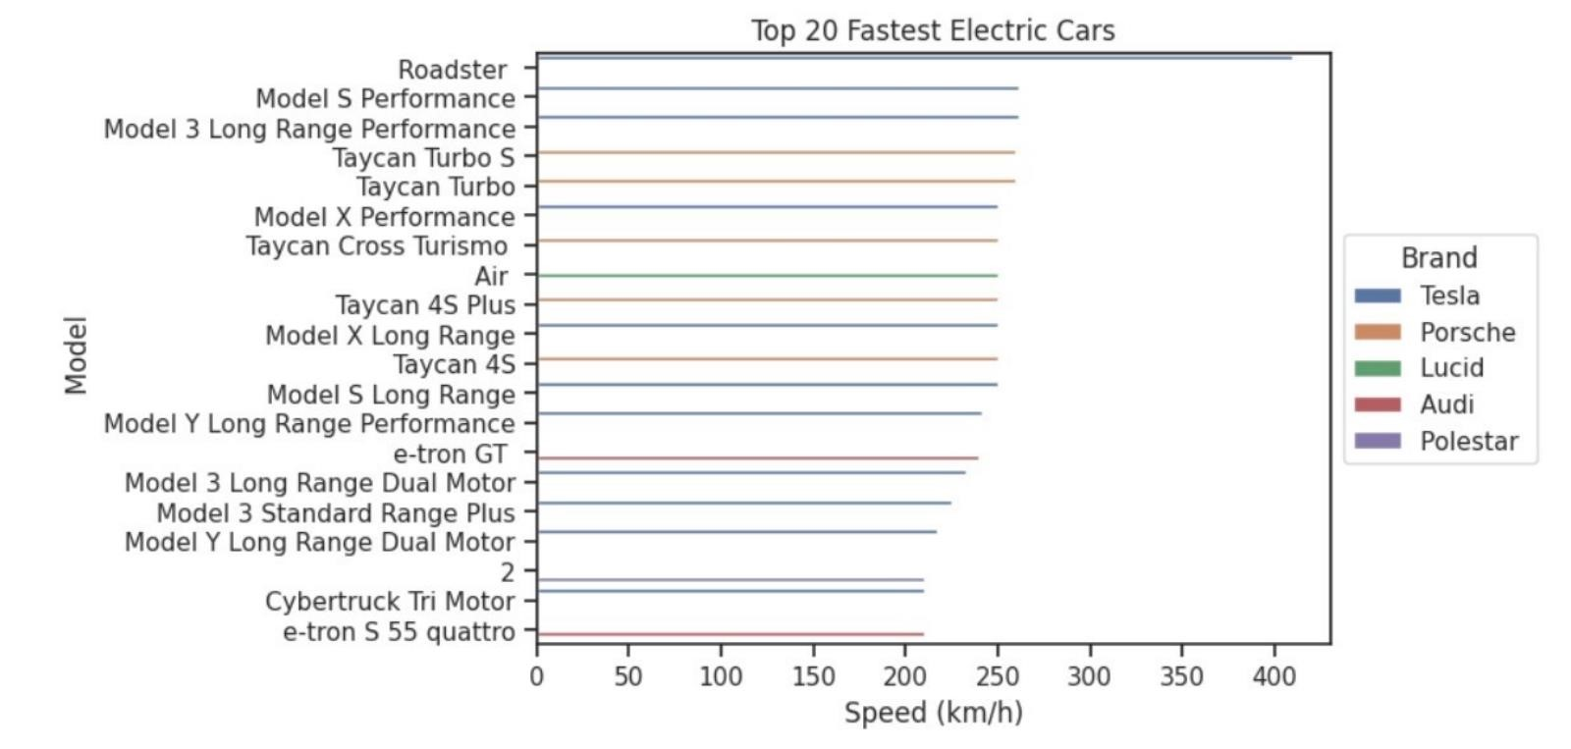

Figure 2: Top-20 fastest EV models and their brands

There is often a relationship between top speed and price in electric vehicles (EVs). Higherpriced EV models tend to offer greater top speeds, reflecting advancements in technology and performance capabilities. However, it’s important to note that other factors, such as battery capacity and powertrain configuration, also influence top speed, making it a multi-dimensional consideration in the overall EV pricing and performance equation. multi-dimensional consideration in the overall EV pricing and performance equation.
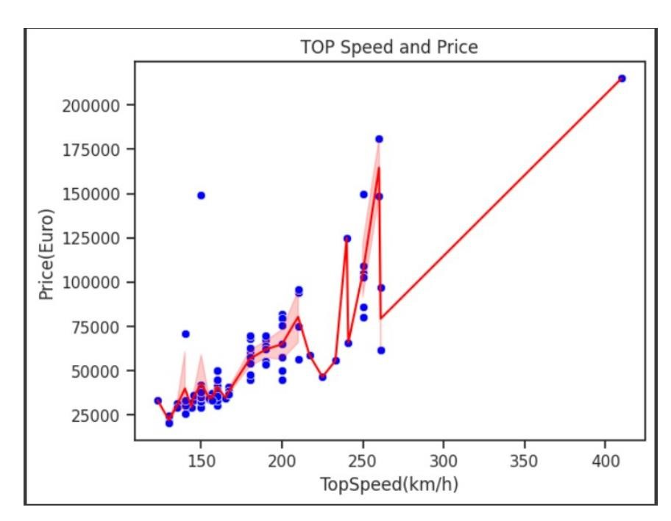

Figure 3 : Speed and Price Graph
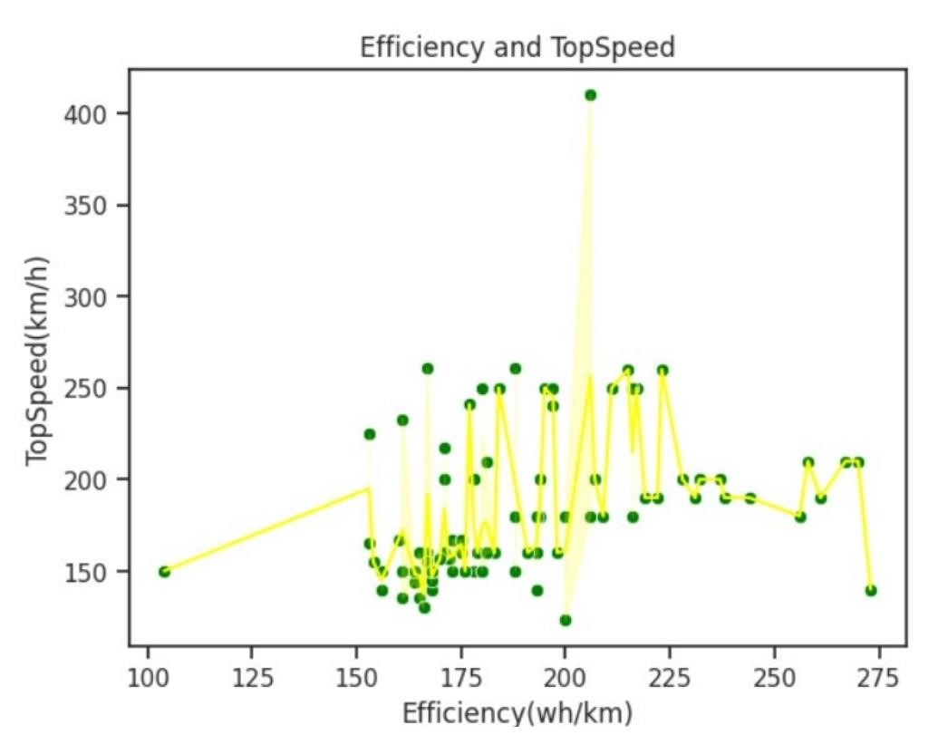
Figure 4: Speed and Efficiency Graph
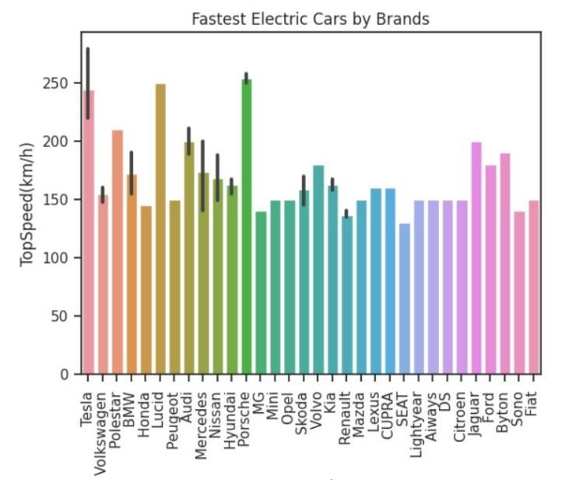

Figure 5 speed and different brands

3.4 K-Mean Clustering For Market Segmentation

• Decomposition of Dataset
After applying Principal Component Analysis (PCA) with a 95 % data impact, the analysis revealed that seven features accounted for the majority of the data variance. These seven features were identified as the most important in the dataset, capturing the key information and reducing the dimensionality of the data while retaining 95% of the original data’s variability. The use of PCA allowed for a more concise representation of the dataset by focusing on the significant features that contribute the most to the overall variation in the data.

• Choosing Number of Clusters
The elbow method is a technique used to determine the optimal number of clusters in K-means clustering. It involves plotting the within-cluster sum of squares (WCSS) against the number of clusters used in the algorithm. The WCSS represents the sum of squared distances between each data point and the centroid of its assigned cluster.
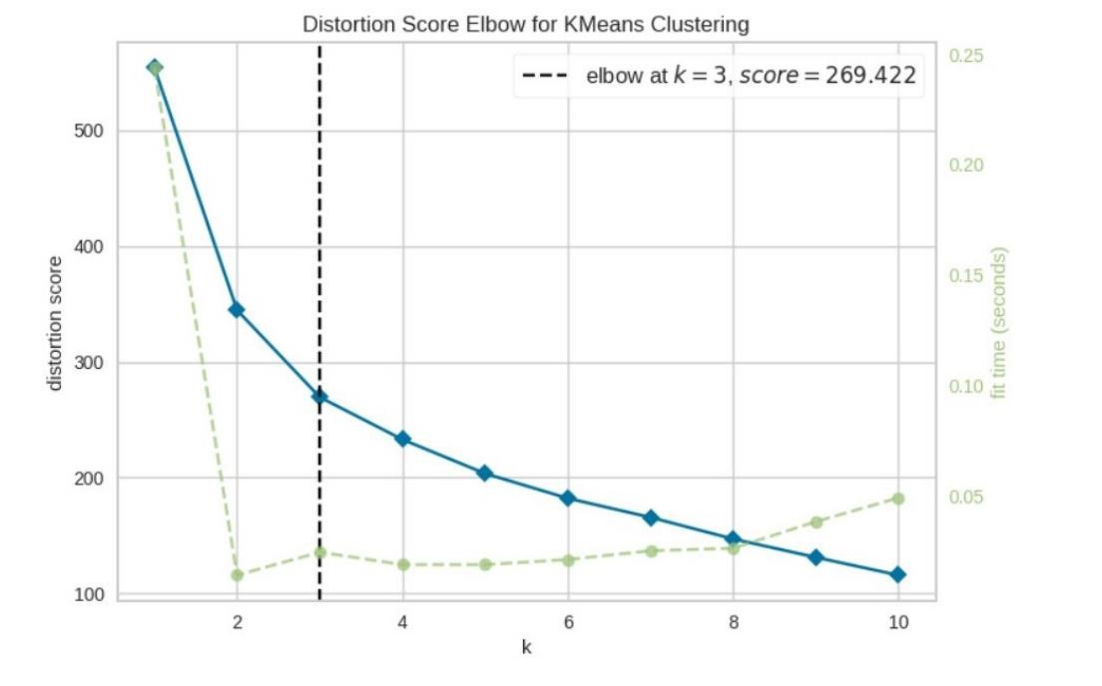

Figure 6 speed and Different Brands

- Clustering
After applying the k-means clustering algorithm we get the three cluster centers. In two dimension graph the centers are as following:
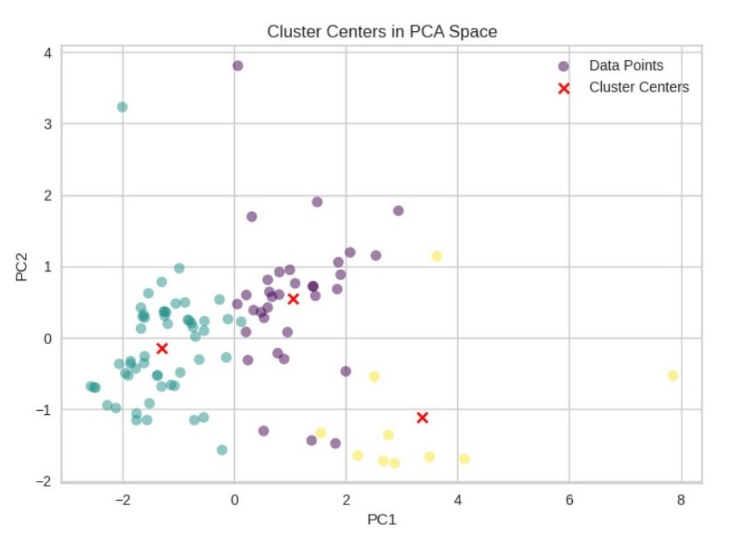
Figure 7: Clusters Centers

Analysis The price of electric vehicles (EVs) plays a crucial role in categorizing them based on price. Please find below a rewritten version of the statement:
The segmentation of electric vehicles (EVs) is significantly influenced by their pricing, as depicted in the following graph

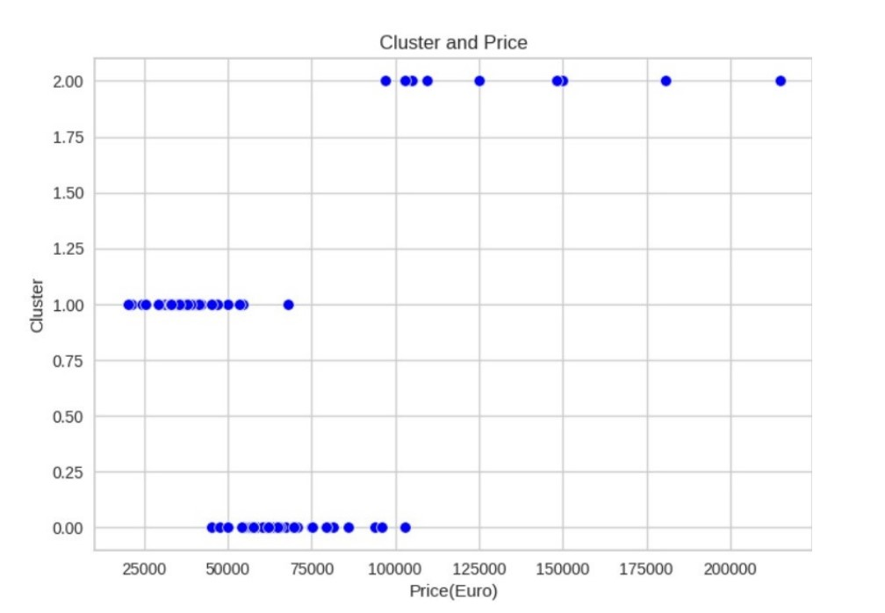

Figure 8: Cluster Centers

4. Customer Segmentation Analysis
The data presented in the following graph is collected from a survey conducted among various individuals, including businessmen, salaried persons, students, and working professionals who are the potential customers of EVs.
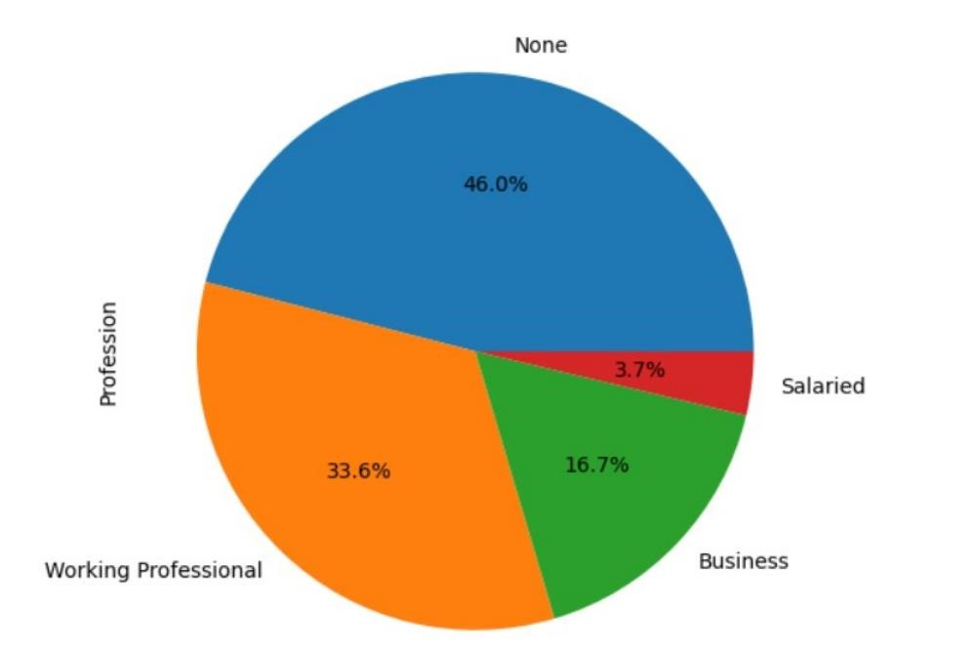

Figure 9: Profession of Customers
• In India, among all the electric vehicles (EVs), four-wheelers are the most demanded, followed by two-wheelers which also have significant demand.
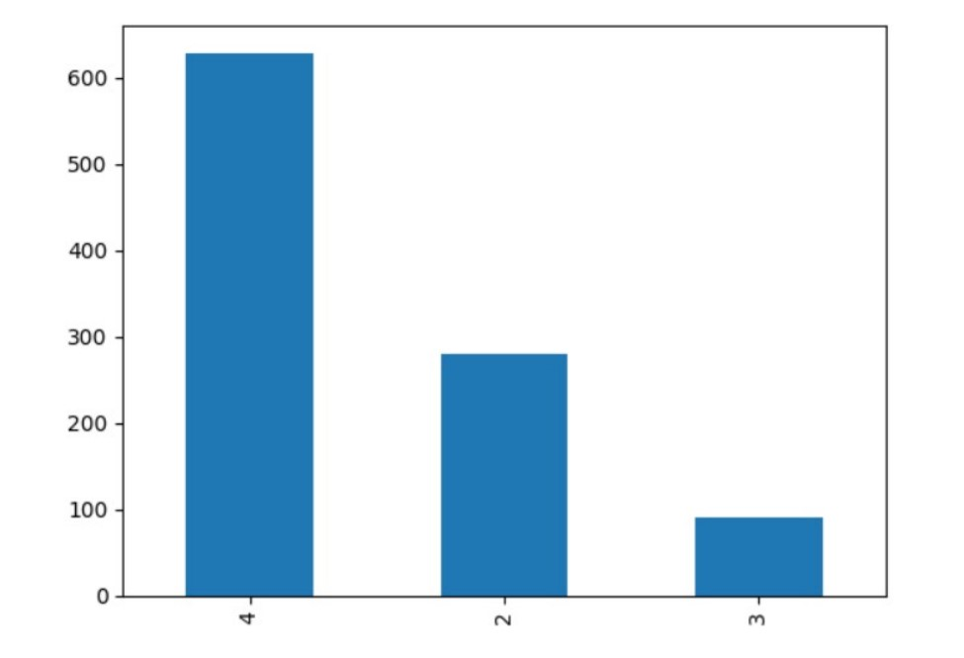

Figure 10 : Demand in several EVs

Correlation Between Several features of customers are given by
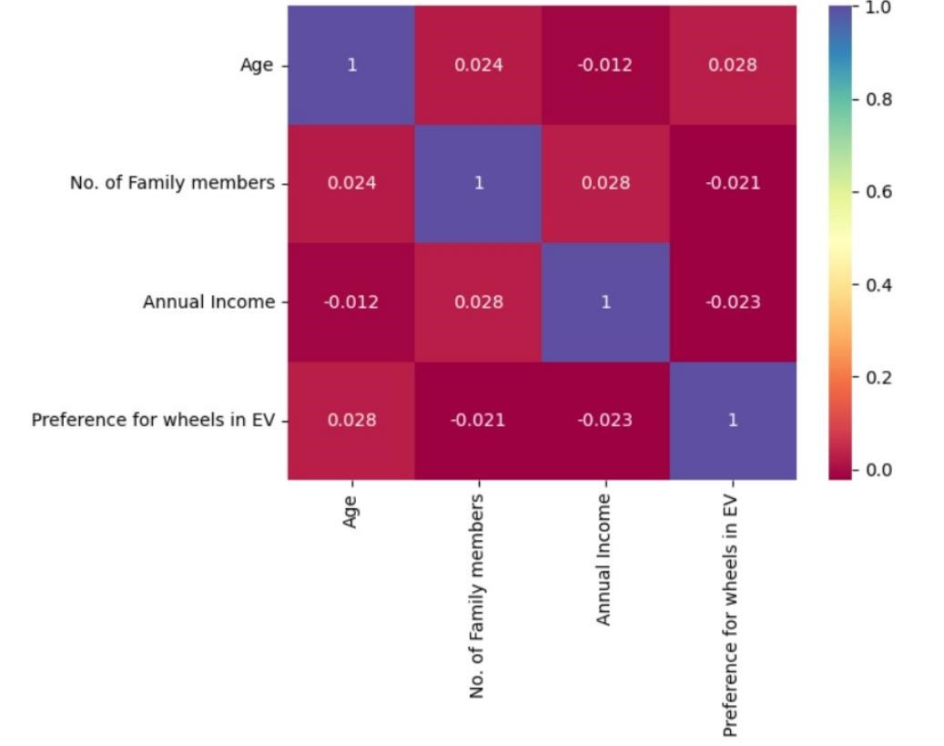

Figure 11: Correlation Between Several Features

• Principal Component Analysis (PCA)
It is utilized to decompose the data, and subsequently, applying the elbow method determines that the optimal number of clusters for k-means clustering is four.

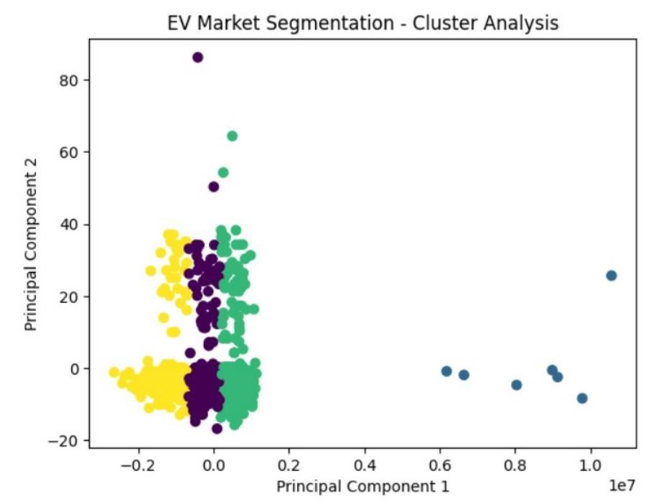0

Figure 12: Cluster Analysis

4.1 Target Market for EVs • Early Adopters:
The initial target market for EVs consisted of environmentally conscious early adopters who were passionate about sustainable transportation. These individuals were willing to embrace new technology and support the transition to electric mobility
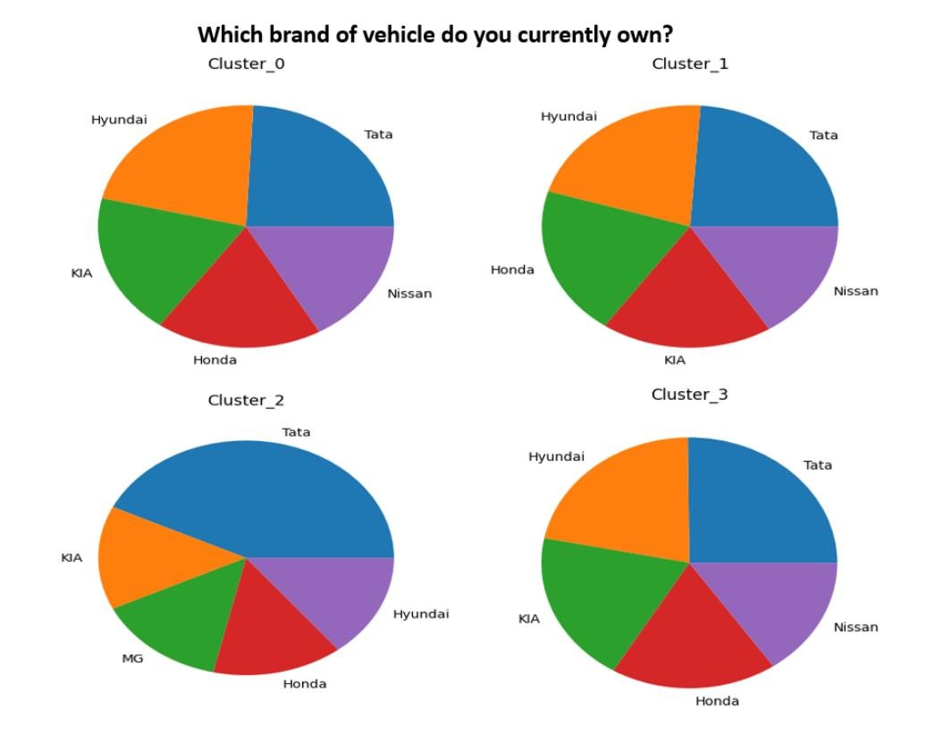

Figure 13: Current Vehicles of Several Customers based on the Clustering

- Tech Enthusiasts:
EVs appeal to technology enthusiasts who appreciate the advanced features and cutting-edge innovations found in electric vehicles. The integration of smart connectivity, advanced infotainment systems, and driver-assistance technologies in EVs attracts those interested in the intersection of technology and transportation.

- Government and Institutional Buyers:
Government agencies, municipalities, and other institutions often prioritize sustainable transportation practices. They may procure electric vehicles for their fleets as part of their commitment to reducing emissions and demonstrating environmental stewardship.

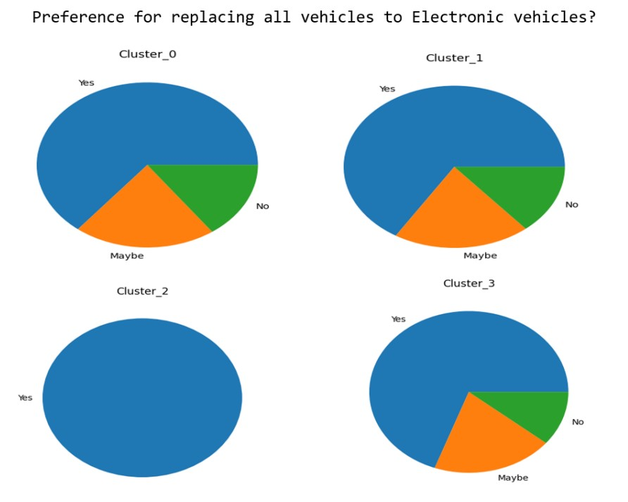
Figure 14 : Potential Customers based on the Clustering
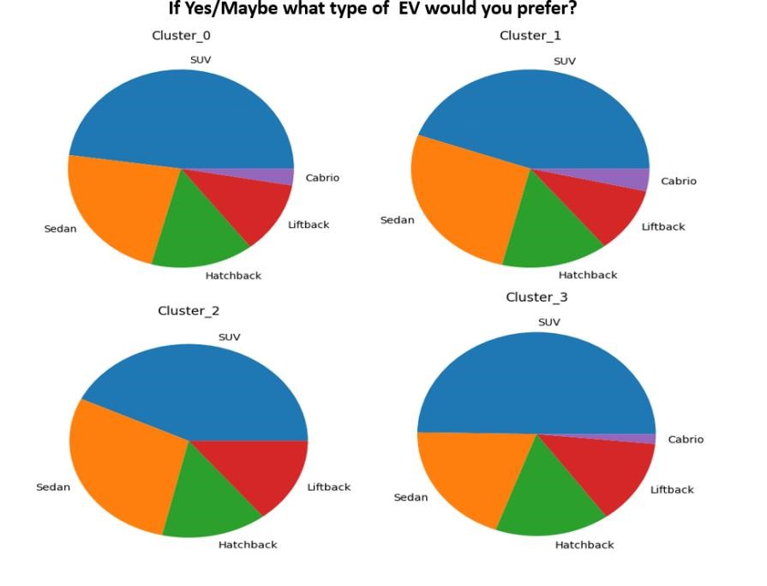Figure 15 : Customer Segments Based on type of four wheelers
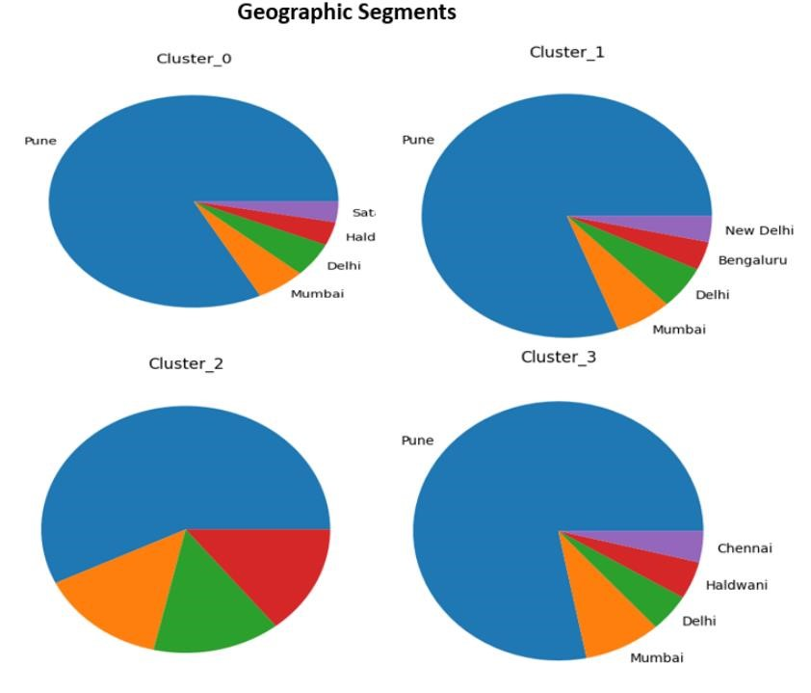
Figure 16 : Geography Based Segmentation

4.2 Price of Four Wheelers EVs in India
The price range of electric vehicles (EVs) in India can vary depending on the model, brand, and specifications. Generally, EV prices in India start from around 5 lakhs (approximately $6,700) for more affordable and compact models and can go up to 50 lakhs (approximately $67,000) or more for higher-end or luxury EVs.
It’s important to note that the prices mentioned are approximate and can vary based on factors such as battery capacity, range, features, and brand positioning. Additionally, government subsidies, incentives, and local taxes can also impact the final price of EVs in India.

5. State Based Analysis of EV market in India
Here, we analyze data related to electric vehicles (EVs) in various states. The data includes information on different categories of EVs and their distribution across states in India. The objectives of this analysis are to:
- Examine the total number of EVs in each state
- Investigate the distribution of EVs by category
- Explore the relationship between two-wheelers and passenger car
  - Data Description
The provided code uses the pandas library in Python to analyze the EV data. The data is represented as a list of lists, where each inner list contains information about a specific state. The columns in the data include the state name, various categories of EVs, and the total number of EVs in each state.
  - Total Electric Vehicles by State
To understand the overall distribution of EVs across different states, the code groups the data by state and calculates the total number of EVs in each state. The states are then sorted in descending order based on the total number of EVs. Figure 17 shows a bar chart representing the total number of EVs by state.
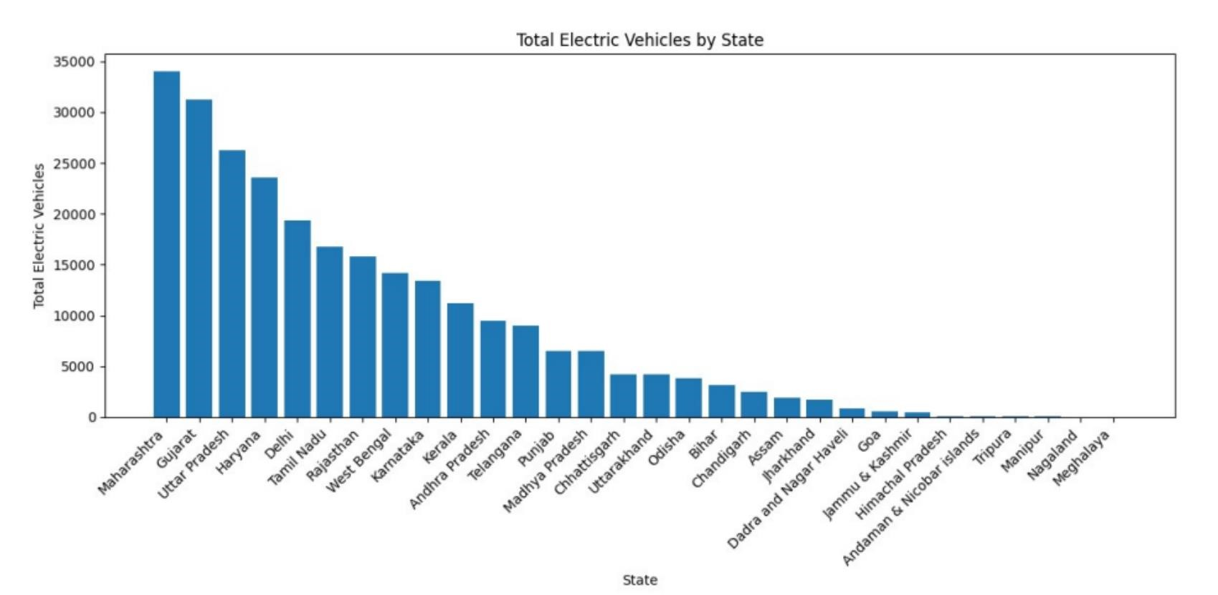

Figure 17: Total Electric Vehicles by State

5.3 Breakdow n of Vehicle Categories by State
To analyze the distribution of EVs by category, a stacked bar chart is created. This chart showcases the number of vehicles in each category for every state. Figure 18 illustrates the breakdown of vehicle categories by state.
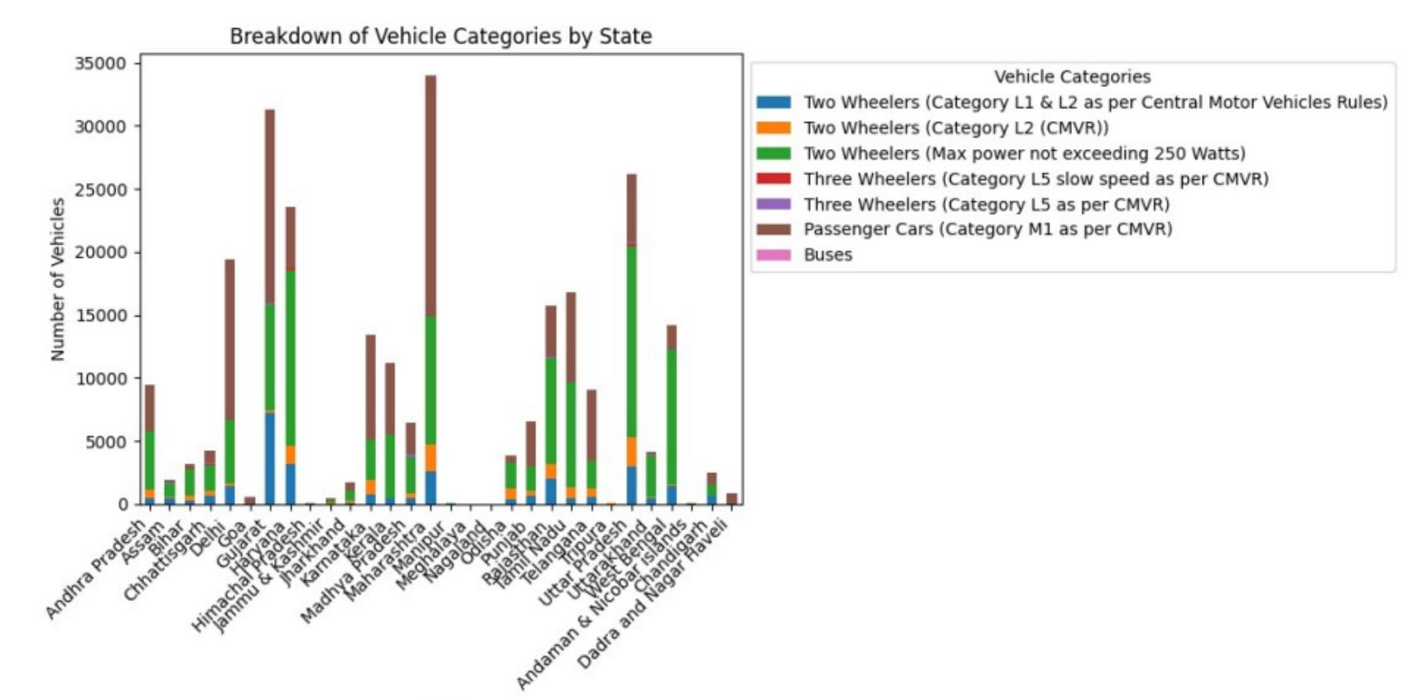Figure 18: Breakdown of Vehicle Categories by State

5.4 Distribution of Vehicles by Category
To gain insights into the distribution of vehicles across different categories, a bar chart is plotted. This chart displays the total number of vehicles in each category. Figure 19 showcases the distribution of vehicles by category.
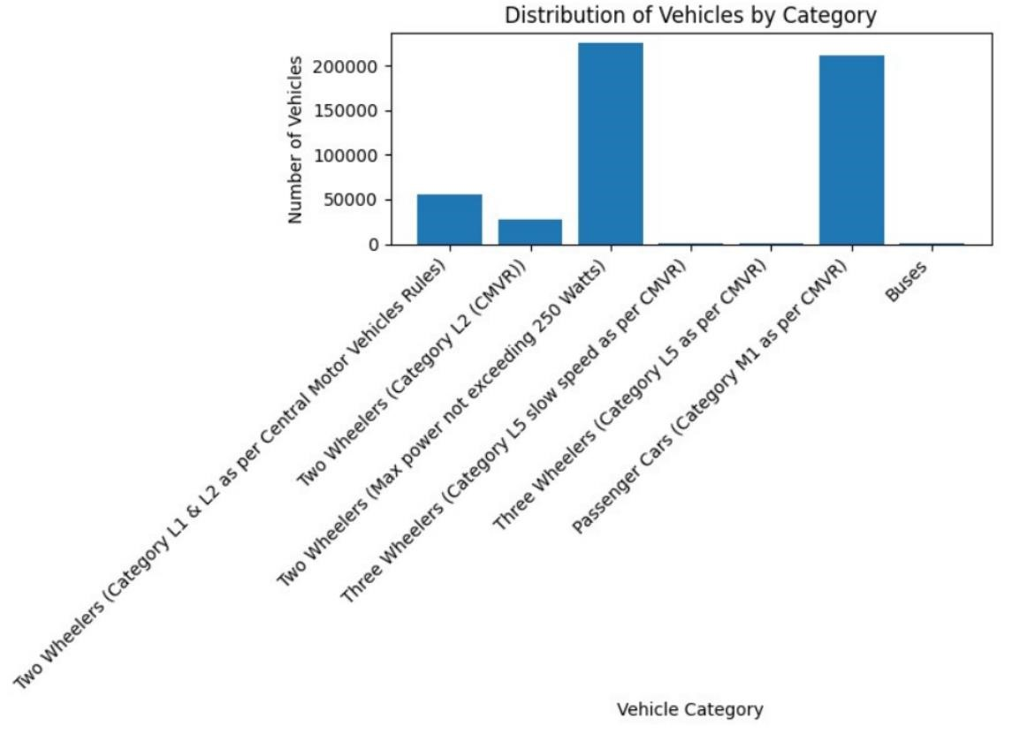
Figure 19: Distribution of Vehicles by Category

5.5 Number of Two-wheelers vs. Number of Passenger Cars in 31 States
To explore the relationship between the number of two-wheelers and passenger cars, a scatter plot is created. The scatter plot showcases the number of twowheelers on the x-axis and the number of passenger cars on the y-axis. Figure 20 represents this relationship.
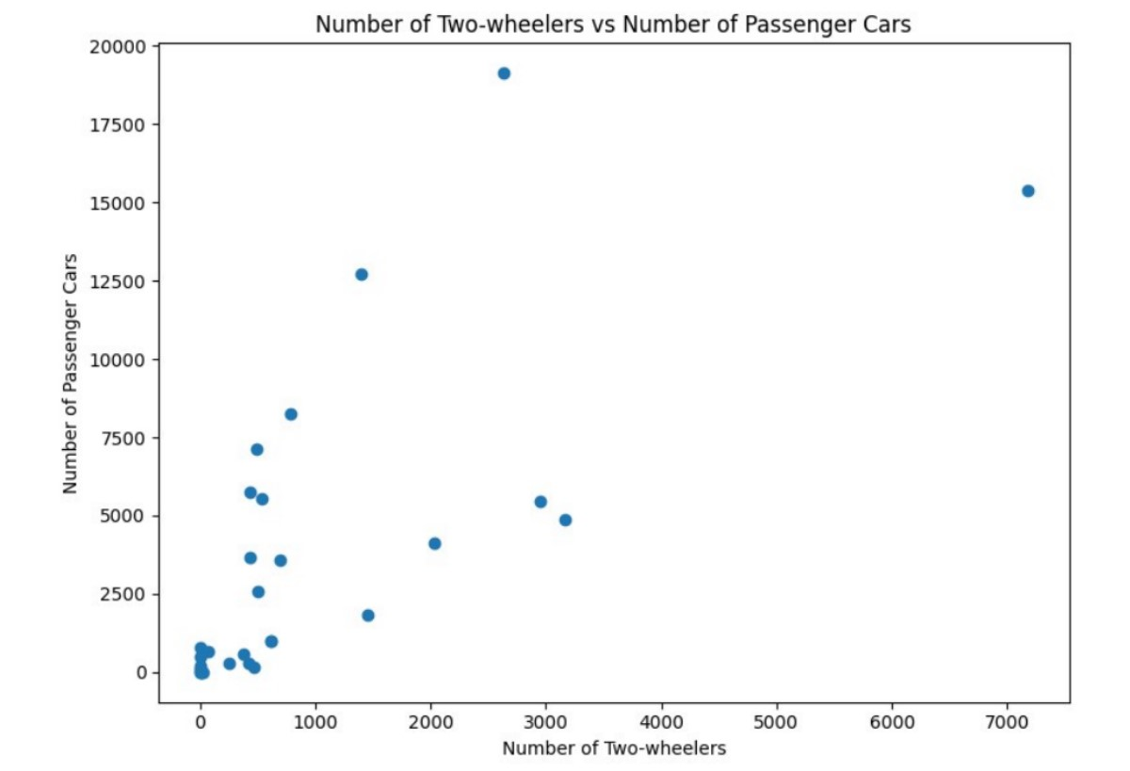

Figure 20: Number of Two-wheelers vs. Number of Passenger Cars

5.6 Results Based on the analysis of the provided EV data, the following conclusions can be drawn:
- The state with the highest number of EVs is Maharashtra, while the state with the lowest number of EVs is Goa.
- Two-wheelers are the most prevalent category of EVs, followed by passenger cars.
- There is a positive correlation between the number of two-wheelers and passenger cars, indicating a potential relationship in their adoption.

6. Conclusion
The growing electric vehicle (EV) market is poised to replace traditional petrol and diesel cars in the future. Advancements in technology, environmental concerns, and government support are driving the shift toward electric mobility. EVs produce zero emissions, reducing carbon footprint and air pollution. Improved battery efficiency, extended ranges, and expanding charging infrastructure alleviate concerns about range anxiety. Decreasing production costs and operational savings make EVs increasingly affordable and competitive. Businesses, fleet operators, and governments recognize the benefits of EV adoption. Although a complete transition will require further investments and infrastructure development, the momentum toward electric mobility is undeniable, leading us to a cleaner and more sustainable transportation future. The reasons for growing EV market are

- Government Incentives:
Various governments provide incentives to encourage the adoption of EVs, such as tax credits, rebates, and grants. These incentives can help offset the initial purchase cost and make EVs more financially attractive to prospective buyers.
Based on the analysis of the Electric Vehicle Market data using K-means clustering,
we have segmented the market into 4 distinct clusters.
- The analysis provides insights into customer demographics, psychographics, and behavior, which can be leveraged for targeted marketing strategies.
Demographic Segments:
- The age group of 28-31 and graduates are crucial target audiences.
- Cluster 1 has the highest average income.
- Pune and Mumbai are important markets, followed by Delhi, Haldwani, and Bengaluru.
Psychographic Segments:
- Single people and families with 3-5 members are key targets.
- 4-wheelers are the most preferred EV types, followed by 2-wheelers and 3-wheelers.
- Tata is the most preferred brand.
Behavioral Segments:
- Most customers are willing to replace their vehicles with EVs, with SUV and Sedan being the preferred types.
- A significant percentage believe EVs are economical and will replace fuel cars in India.
- The majority are willing to spend up to 15 lakhs on an EV.
Recommendations:
- Focus marketing efforts on the age group of 28-31 and graduates, particularly those in Cluster 1 (highest average income).
- Target single people and families with 3-5 members.
- Emphasize the benefits of 4-wheel EVs, especially SUVs and Sedans, from brands like Tata, Hyundai, and Kia.
- Promote the economic advantages of EVs and their potential to replace fuel cars in India.
- Offer attractive pricing options, potentially focusing on price ranges below 15 lakhs.
- Expand market reach to cities like Pune, Mumbai, Delhi, Haldwani, and Bengaluru.

